**Casual Mechanics**

**4 Keys to Fun**

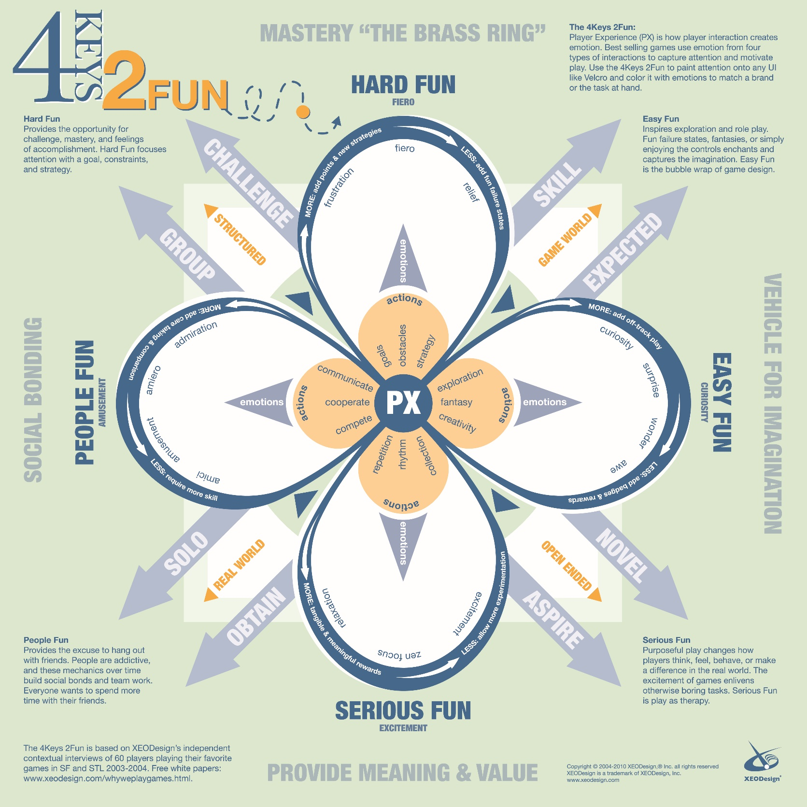Before we look at the kind of game we want to be making for a casual audience, we may want to first look at Nicole Lazzaro’s 4 Pillars of Fun.

Based on examples of games I have played, one tap mechanic titles all feature a clear learn, practice and master gameplay loop (One More Line, Break Liner, Rooms of Doom). Learning and mastering mechanics is a typical hallmark of Hard Fun, that feeling of initial frustration when you struggle through a section of the game, then the relief, or fiero, when you overcome it. The reason for this, I think, is that players want a quick feeling of relief and success in between their daily duties. A quick shot of dopamine to tell them they’re doing okay, so to speak.

Of course, our game is a multiplayer title, so People Fun is absolutely something we should talk about. We have already brought attention to schadenfreude, so we know what angle we want to approach this element of fun with. We do not need to worry about feelings like admiration or companionship; as our game is purely adversarial, thus should draw out feelings of competition.

Serious Fun comes into ‘casual mechanics’ too. Flow state is a significant part of what serious fun is, and a game with one tap mechanics absolutely needs rhythm to avoid being stale after a time. Excitement also comes into serious fun, and a competition needs excitement (hype, I suppose) to be compelling.

Funnily enough, Easy Fun won’t be as big a component of our title as we may have initially thought. The game takes place on a singular screen, so the feeling of exploration is non-existent. Curiosity and awe could be drawn from our theme, but it isn’t something we have been designing in mind with so far.

Many casual titles on PC and Smartphone do use easy fun mechanics, clicker games for example, to shower their players in rewards to fuel their curiosity to make them continue playing. I think with a competitive element in our game, however, this may be an unnecessary mechanic, that would muddy the scope of our game.

**PopCap: the 10 Secrets of Game Design**

<https://www.theguardian.com/technology/gamesblog/2012/aug/08/popcap-secrets-of-game-design>

This blog post makes several interesting points, but the one that caught my interest was secret number 2, which claims we should “Design games for everyone”

PopCap Senior Producer Matthew Johnston claims “We’ve never made games for gamers, we’ve made games for people”. They also claim that, although their games often have a bigger female player base than male, they do not let that affect their games mechanics or design. Maybe we should think less about demographics and psychographics, but more about how we can appeal to everybody.

Secret number 6 is also interesting, in which we are recommended we “Go back to the basics for inspiration”. The implication here is less that we should worry about our game mechanics so much as the gratification of the player. We’ve talked about instant gratification rewards and dopamine before, so we may want to consider shifting our focus away from finding an excellent mechanic and think more about how we can make the player enjoy every other aspect of the game.

**A weird little aside**

A couple days ago there was a party in my flat. We had some balloons, and they still litter the floor of the common room, half because we’re all incredibly lazy, but also because, honestly, playing with them is pretty fun.

So, naturally, I decided to start analysing *why* knocking a balloon all over the place is so fun. I realised the balloon makes a satisfying little ‘bop’ every time you hit it. I appreciated the speed at which I could bounce it, or how I slowly started to get better at keeping it up in the air.

So, it was all about satisfying sounds, animations and mastery. It didn’t matter that it was a generic, simple game, every other part of the design, so to speak, made it fun. Doesn’t this sound familiar? Bouncing a balloon around my flat really helped me visualise the very core of what we as game designers are currently trying to design.

To put it simply, A very simple, basic game can be very entertaining if everything that surrounds that mechanic is enjoyable and gratifying in some way. I think that should be our focus more so than the mechanic of the game itself.